Hello,

I have attached Assignment4_Chandru_Jeyanth.zip. The attachment consists of the following files.

AboutUs.php - consists of the details about the assignment/ student

cheapbooks.sql - Database for the web application

basic.php - The header common for all the pages

cart.php – The code for the Shopping basket

connect.php - The code for database connection﻿﻿﻿﻿ with MySQL

css.css - The stylings for the project inaddtion to the bootstrap CDN

customer.php – The login page of the web application

default.php - The home page for the project

js.js - The javascript required for the project

newuser.php – Register page for the project

search.php – Search page for the web application

I have attached the snapshot of the display of all the pages.

**Steps:**

1. Extract the zip files into a specific folder
2. Load the sql file into ‘cheapbooks’ database.
3. Execute all the queries from the .sql file.
4. Start the execution with the default.php
5. The contains table is inserted and deleted for each session
6. At the click of buy button, The values are inserted into the shippingorder table.
7. Once session is over / clicking of the buy button, the values in the contains and shoppingbasket table are deleted.

Thanks and Regards,

Jeyanth Chandru

Default.php

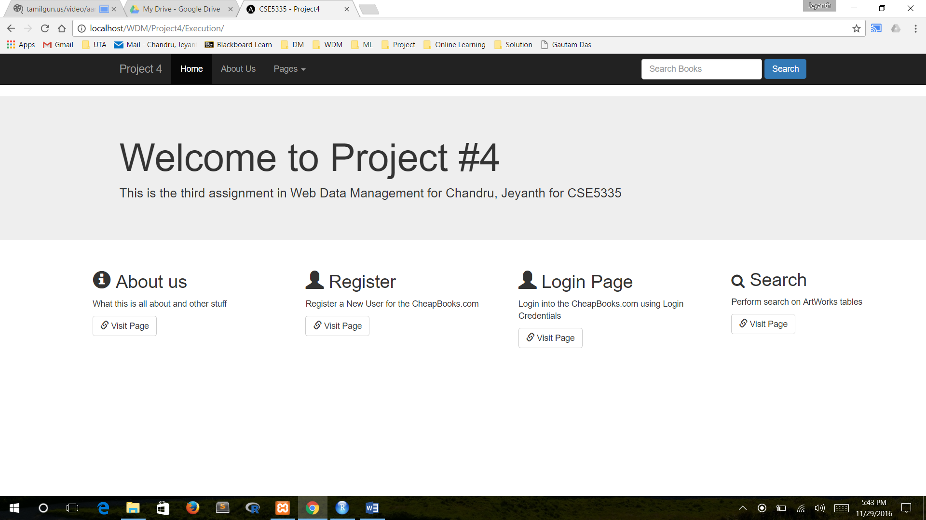

AboutUs.php

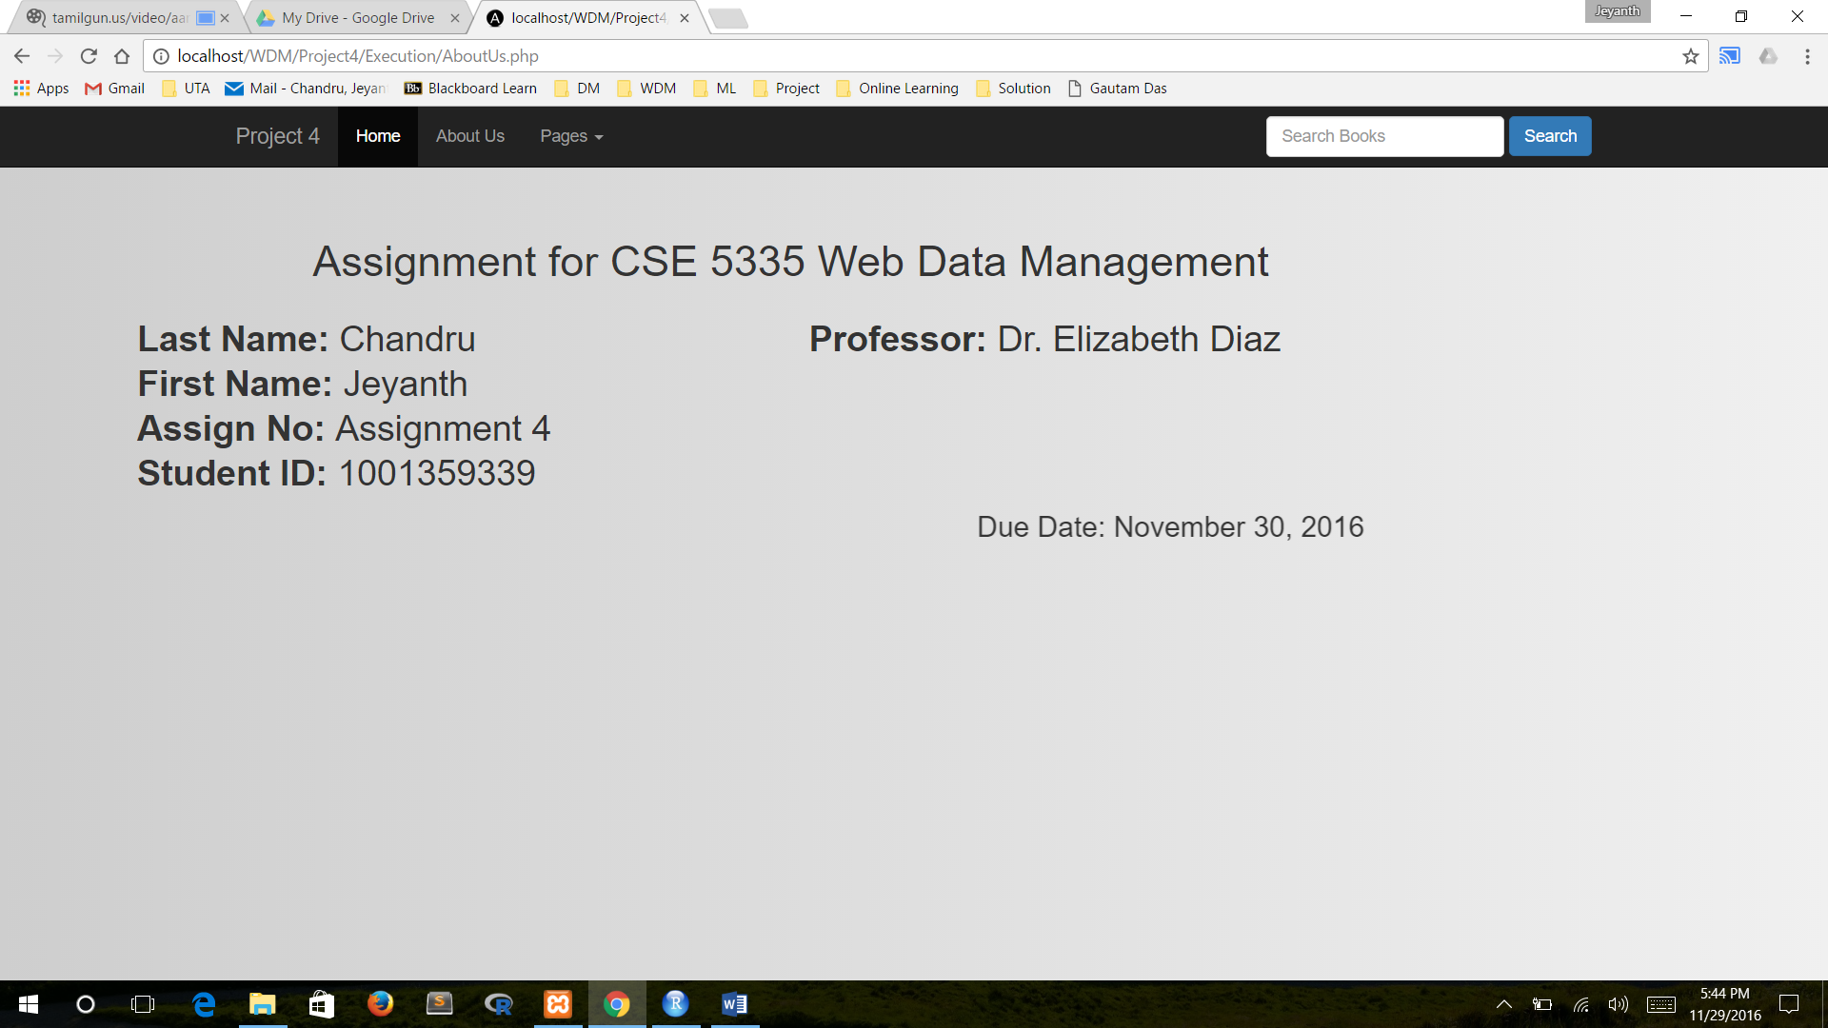

Register.php

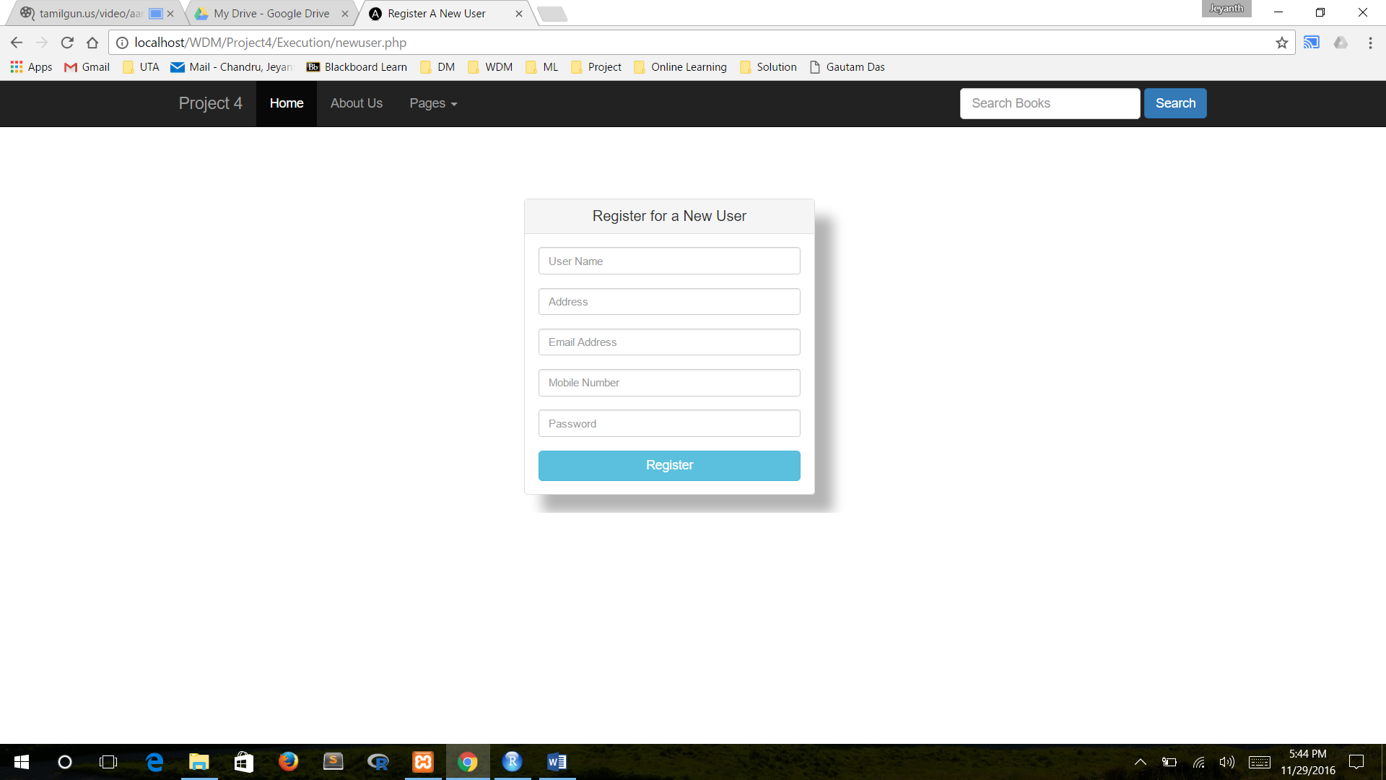

Register Success Page

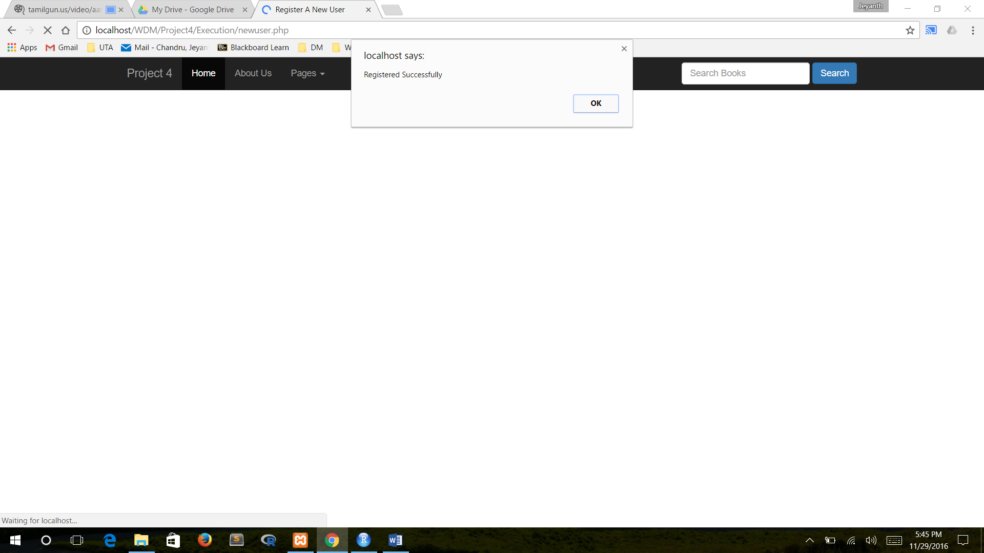

Login Page

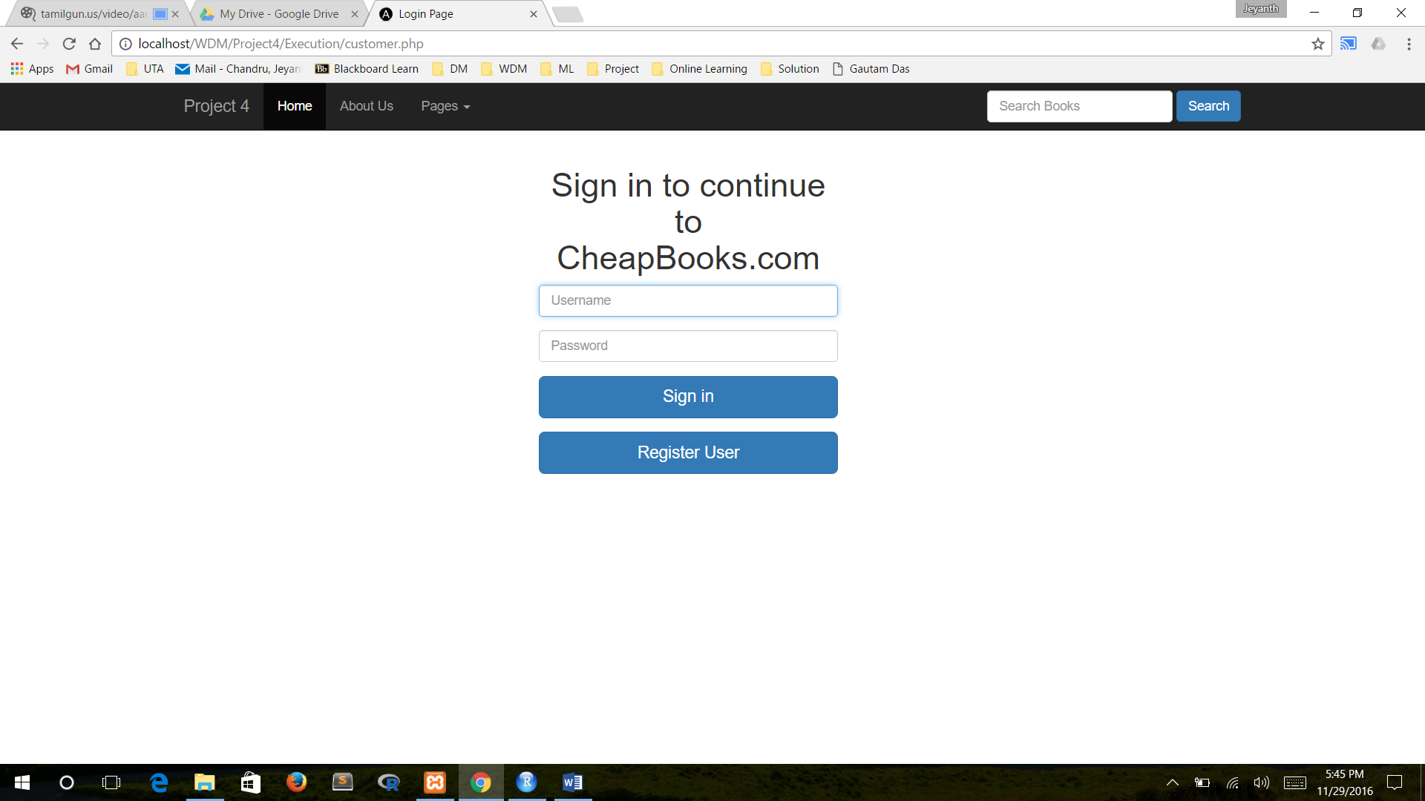

Login Success Page

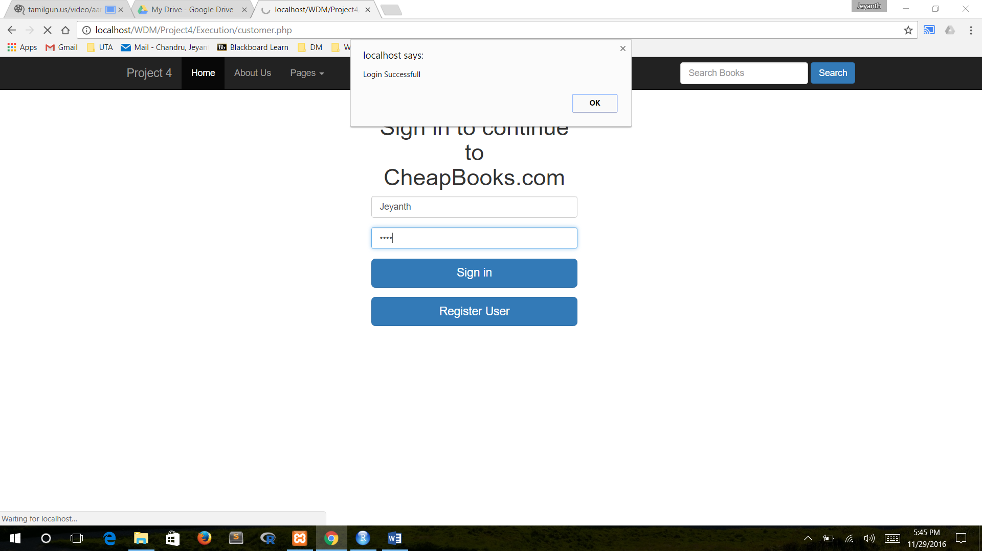

Login Denied Page

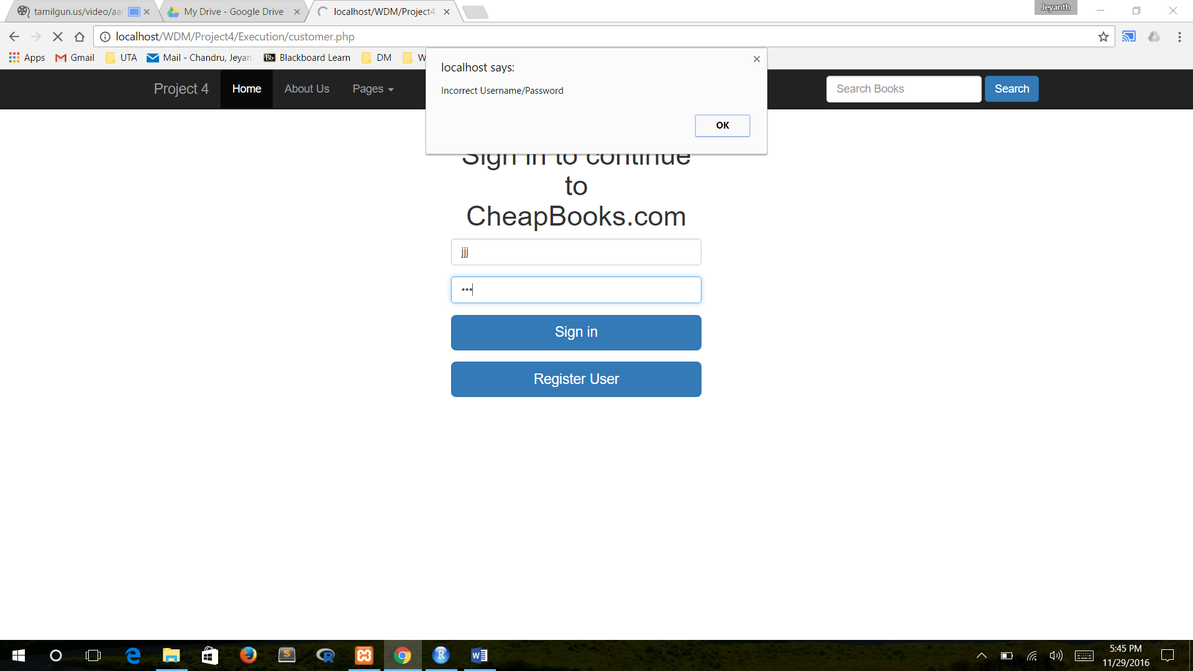

Search Page

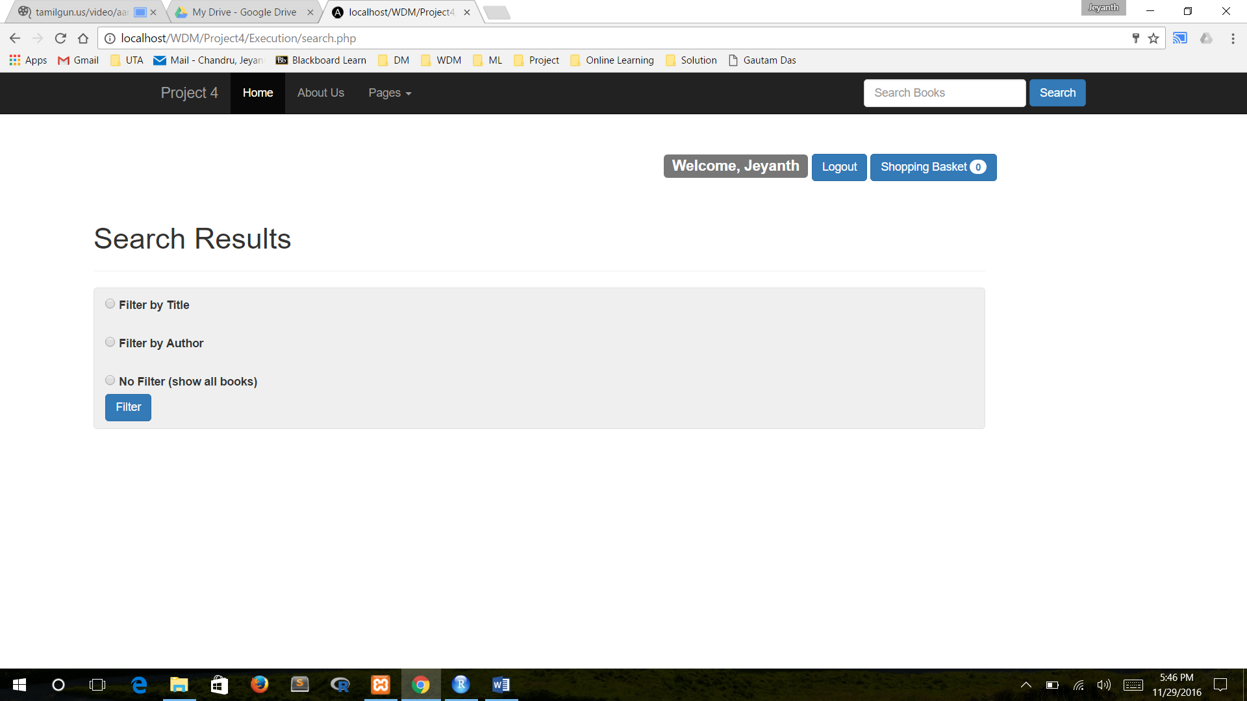

Display All Results

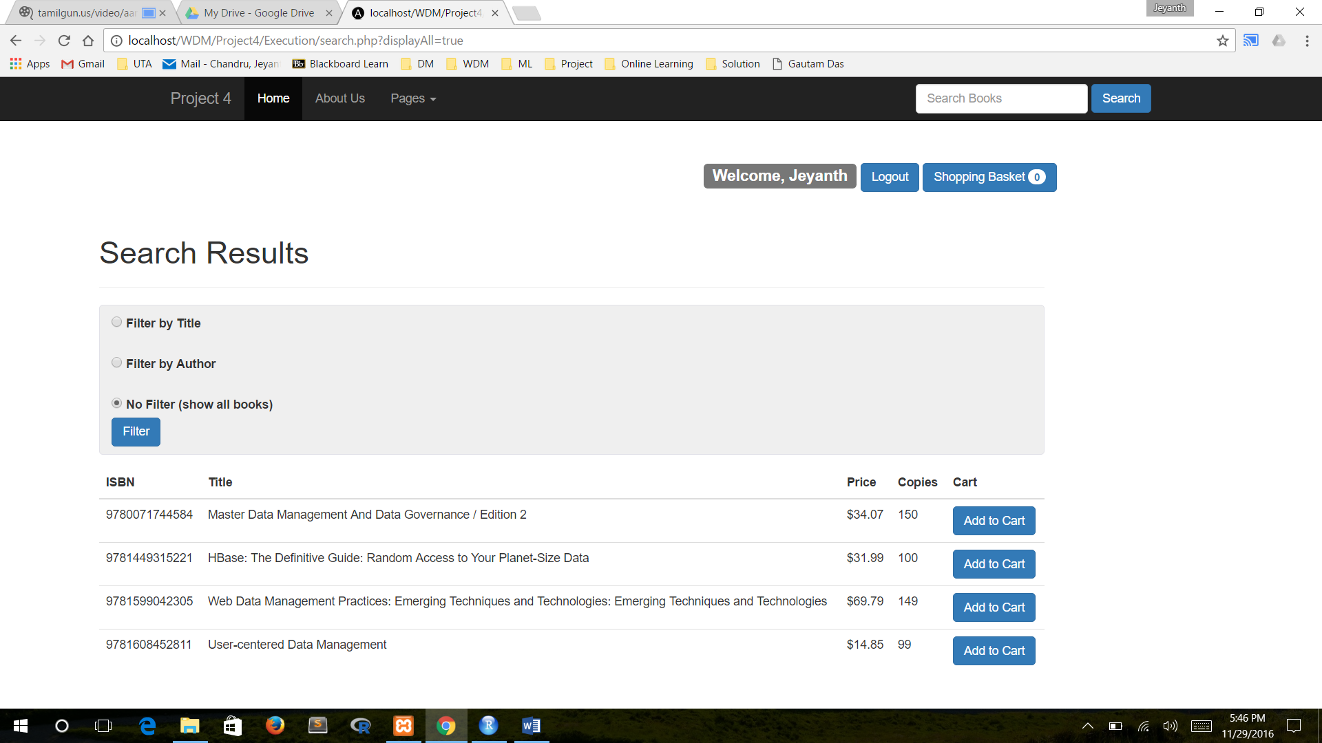

Display by Author

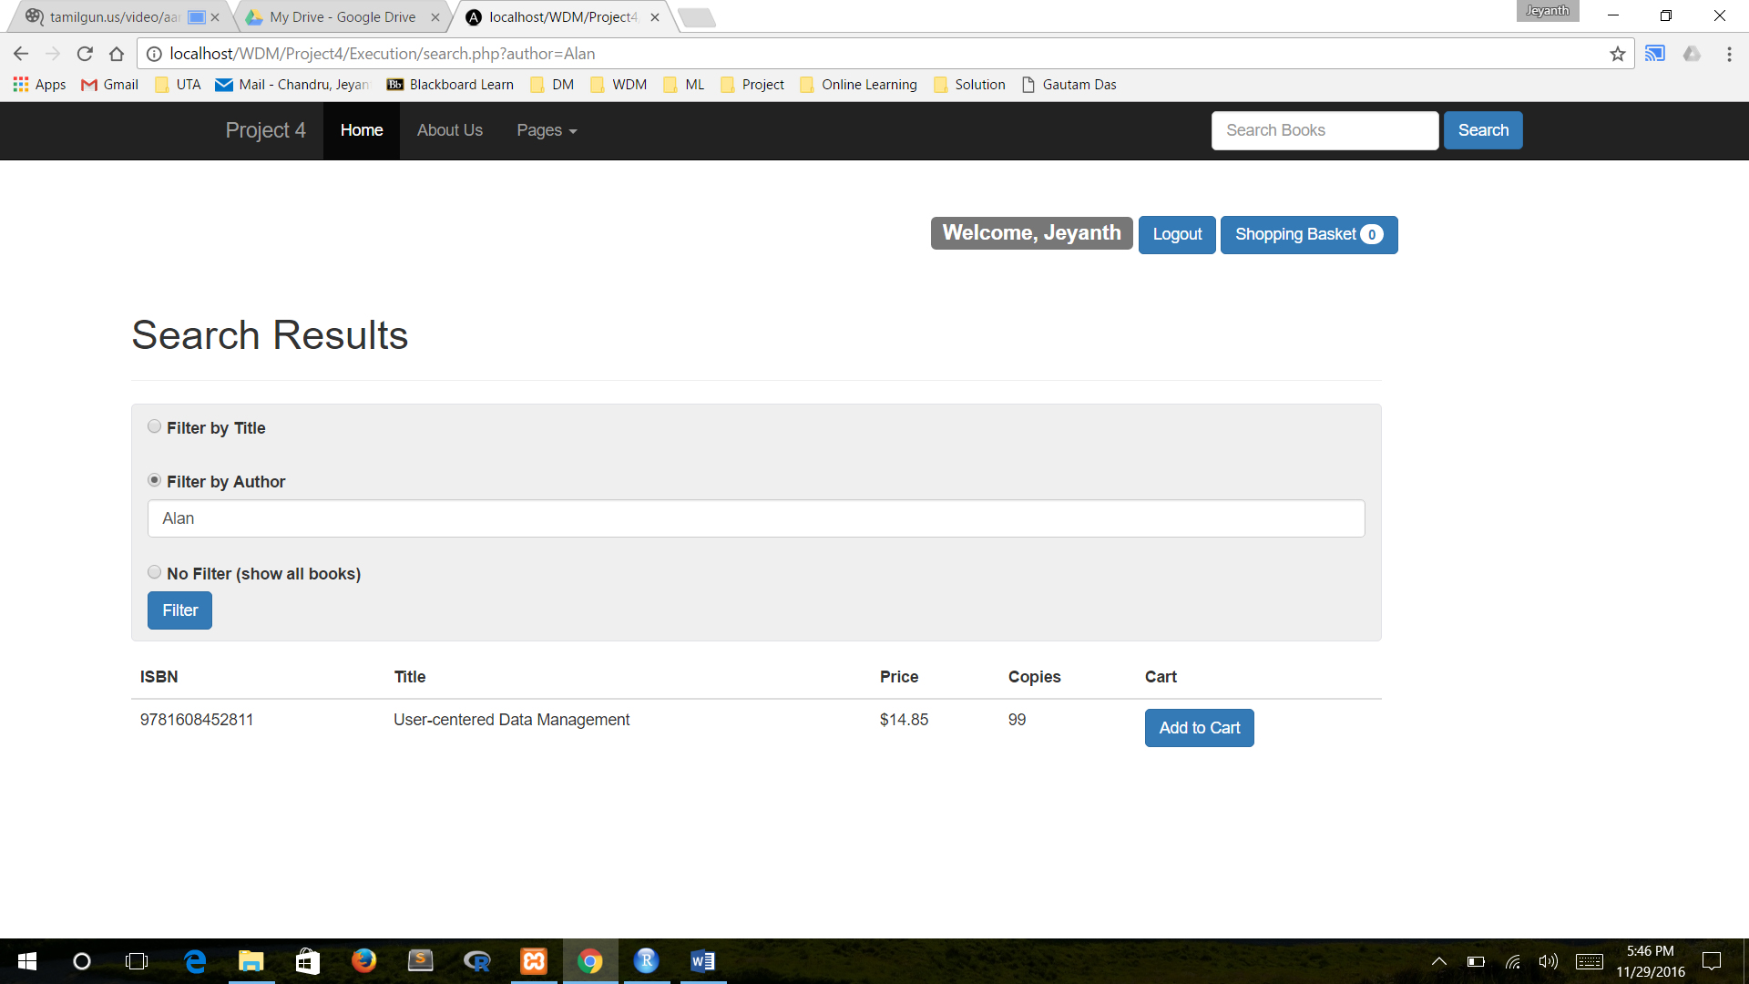

Display by Title Page

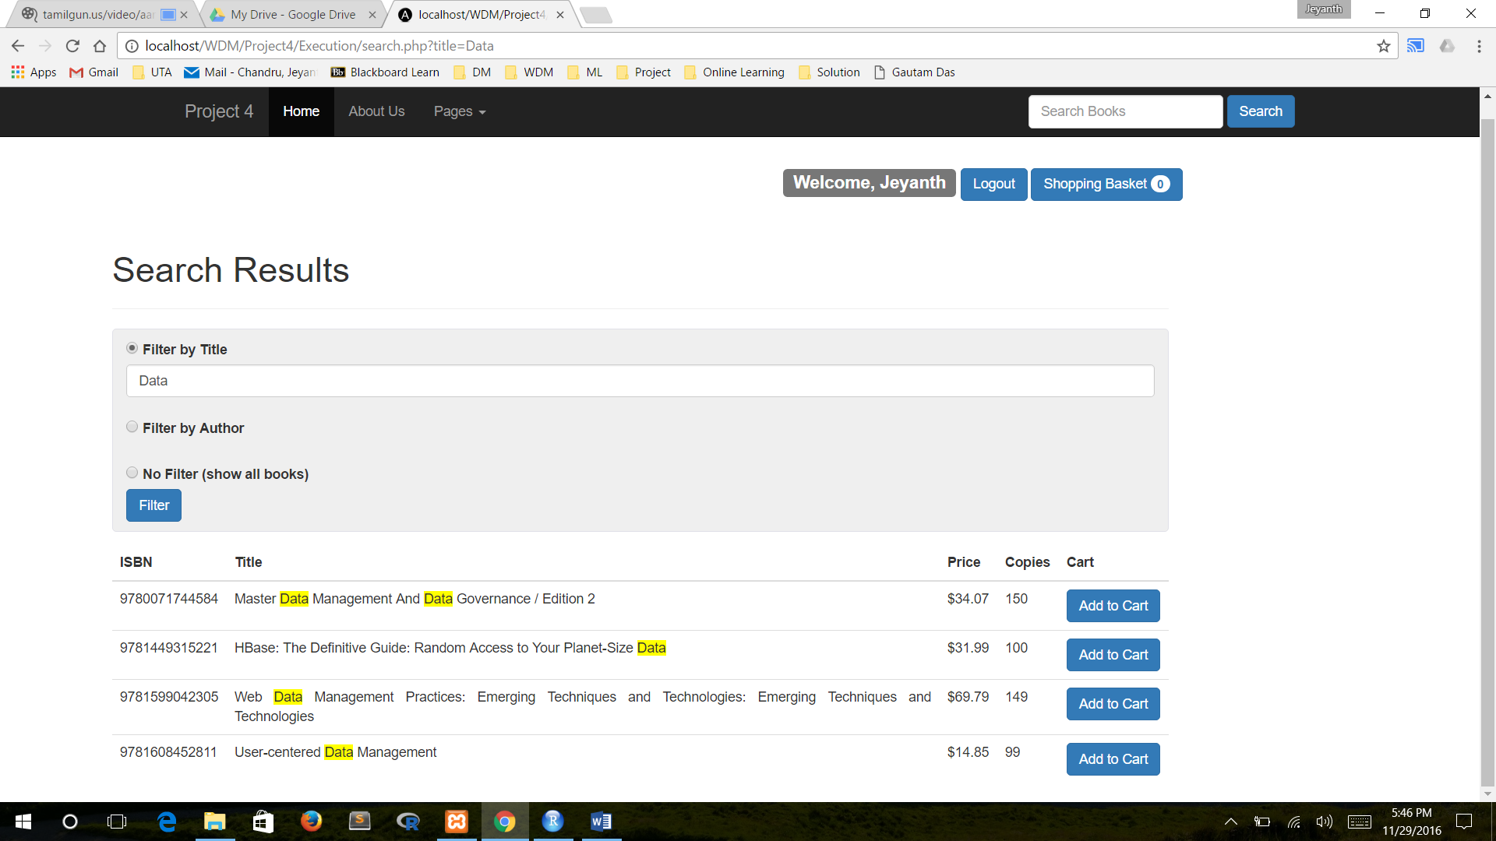

Add Cart Page

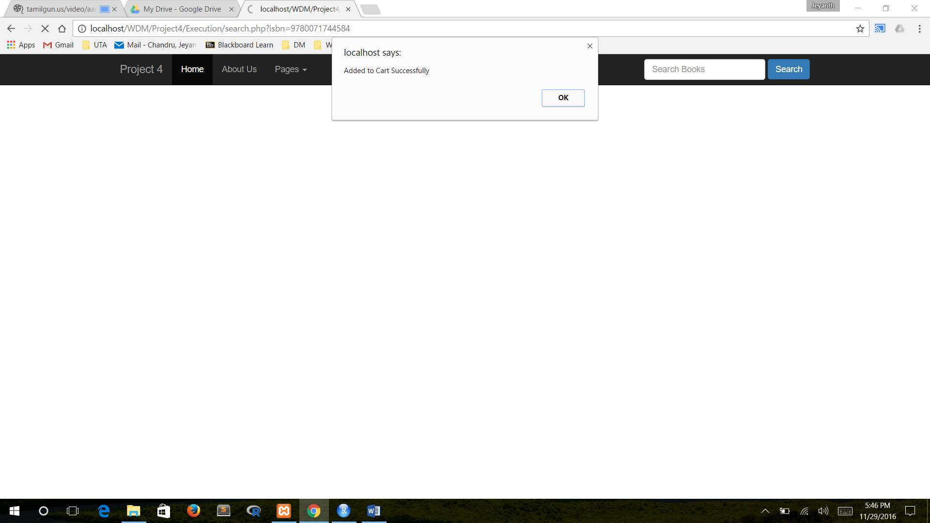

Shopping Basket Page

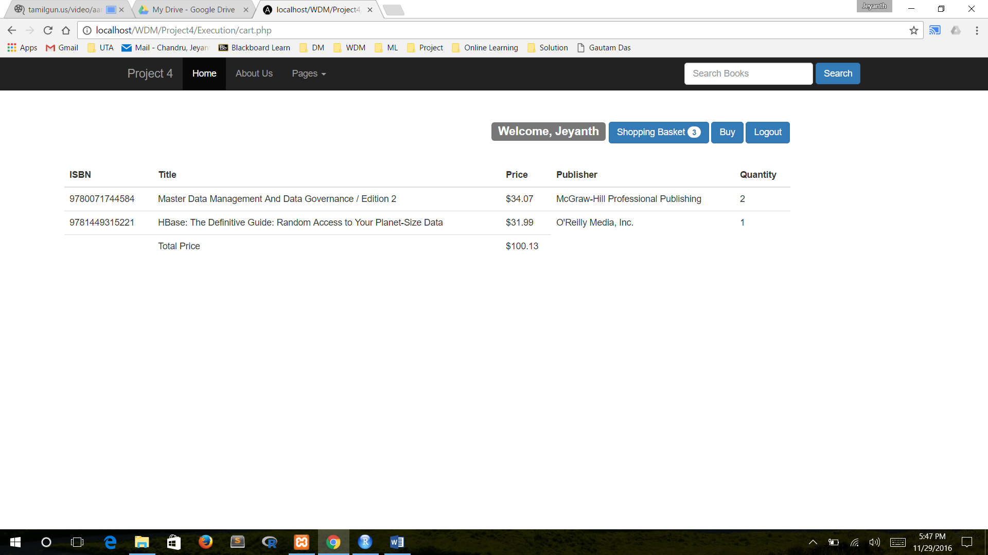

Bought Page

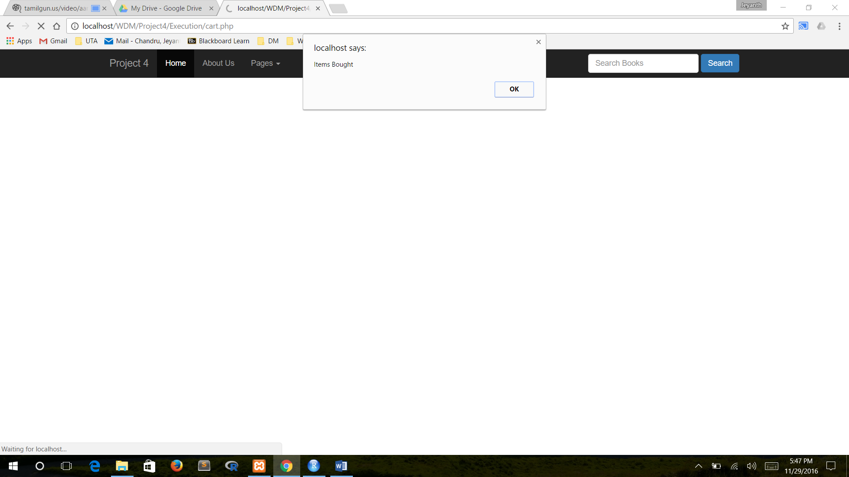

Author Table

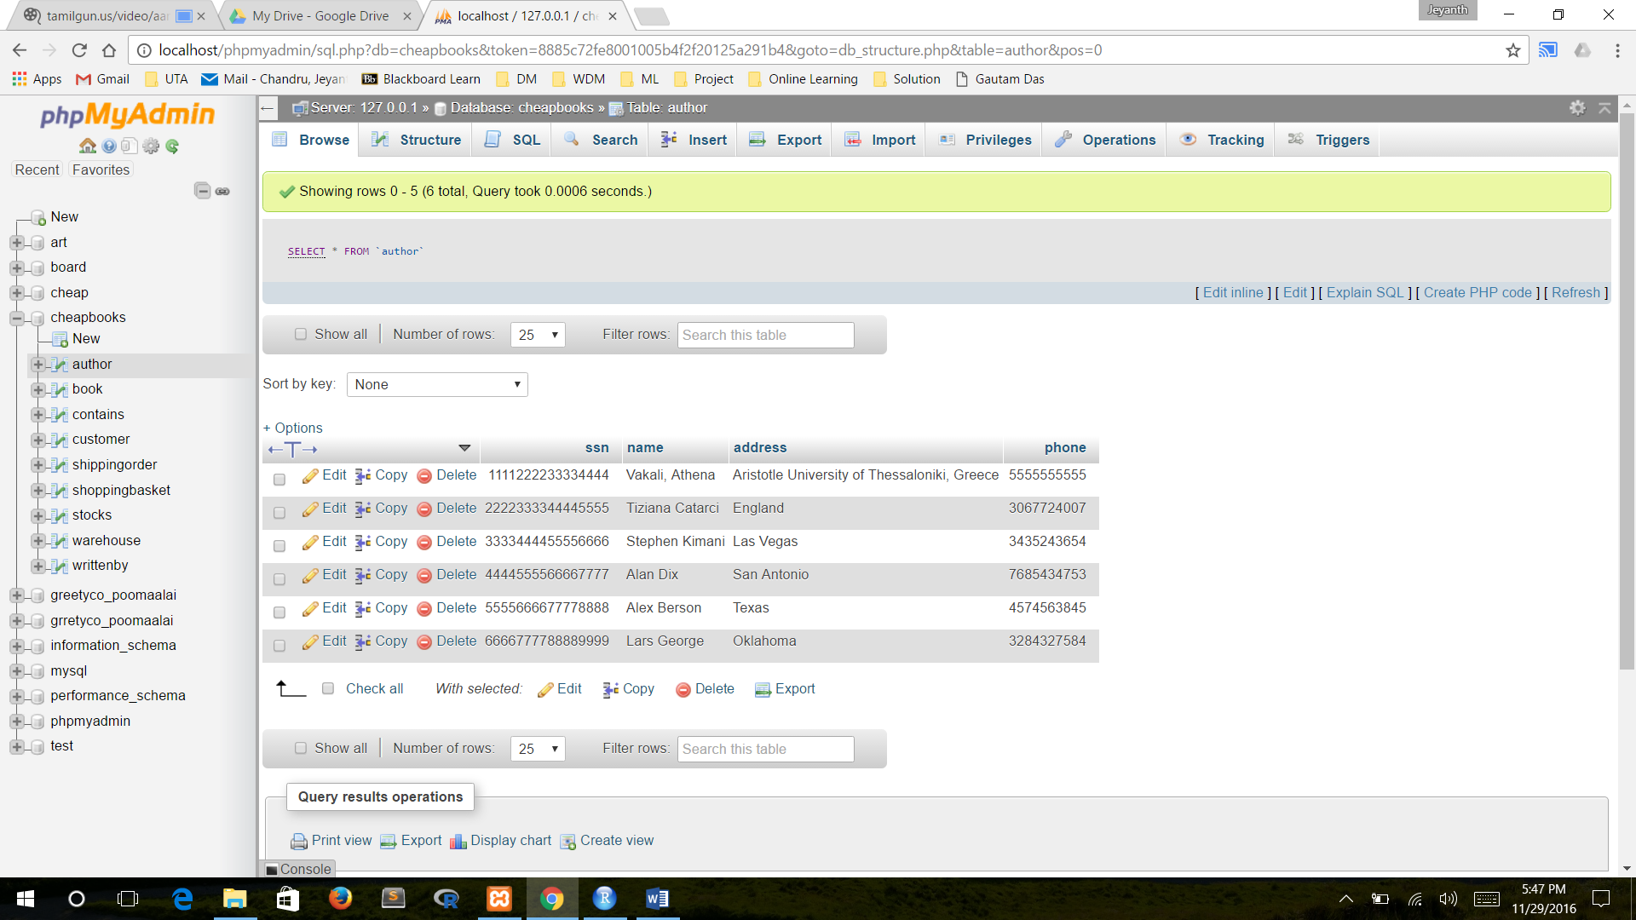

Book Table

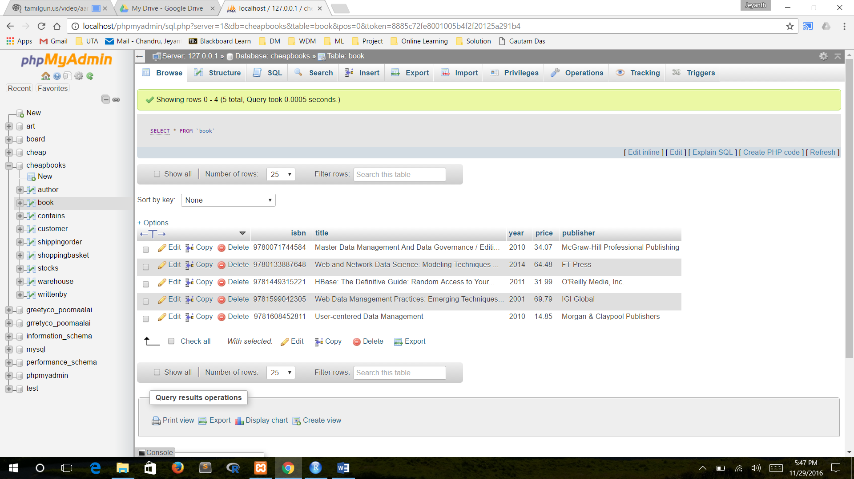

Customer Table

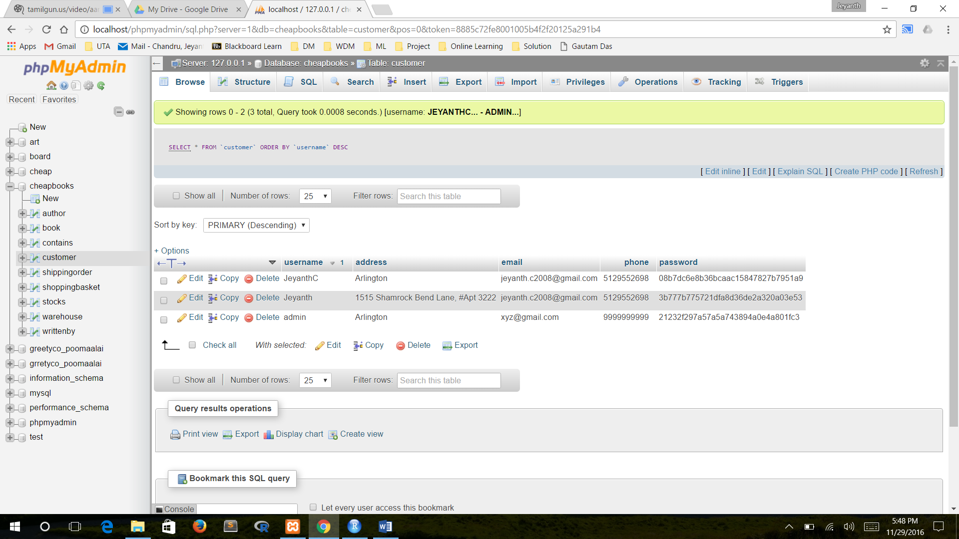

Shipping Order Table

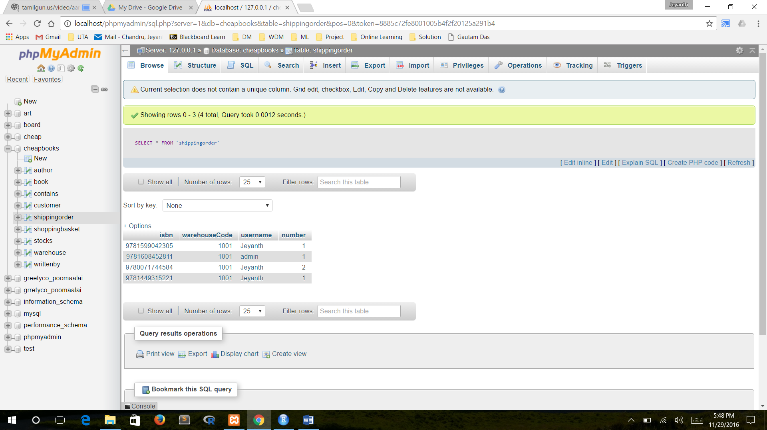

Stocks Table

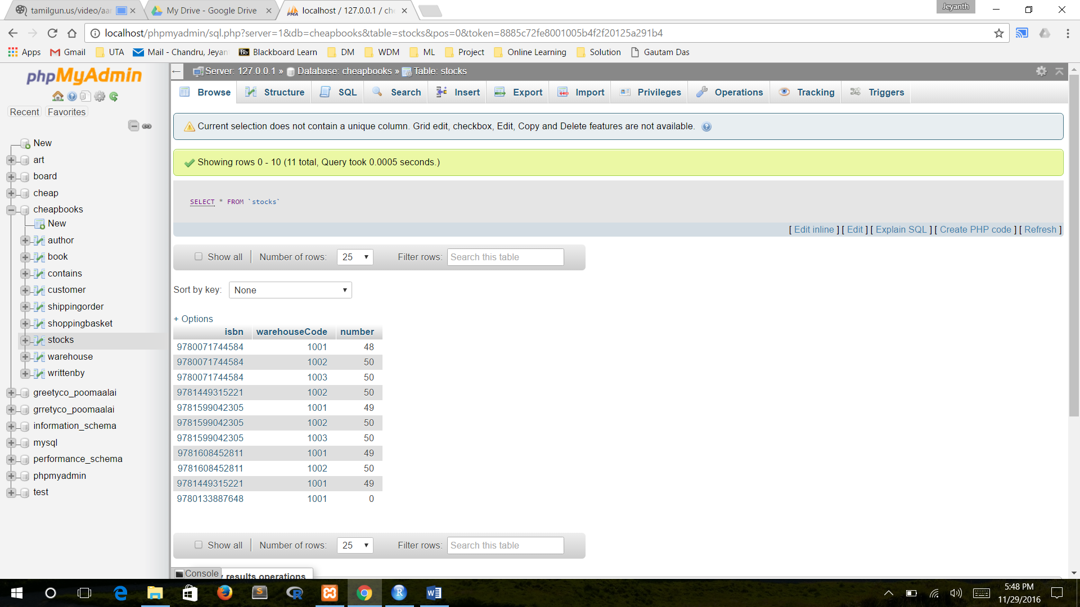

Warehouse Table

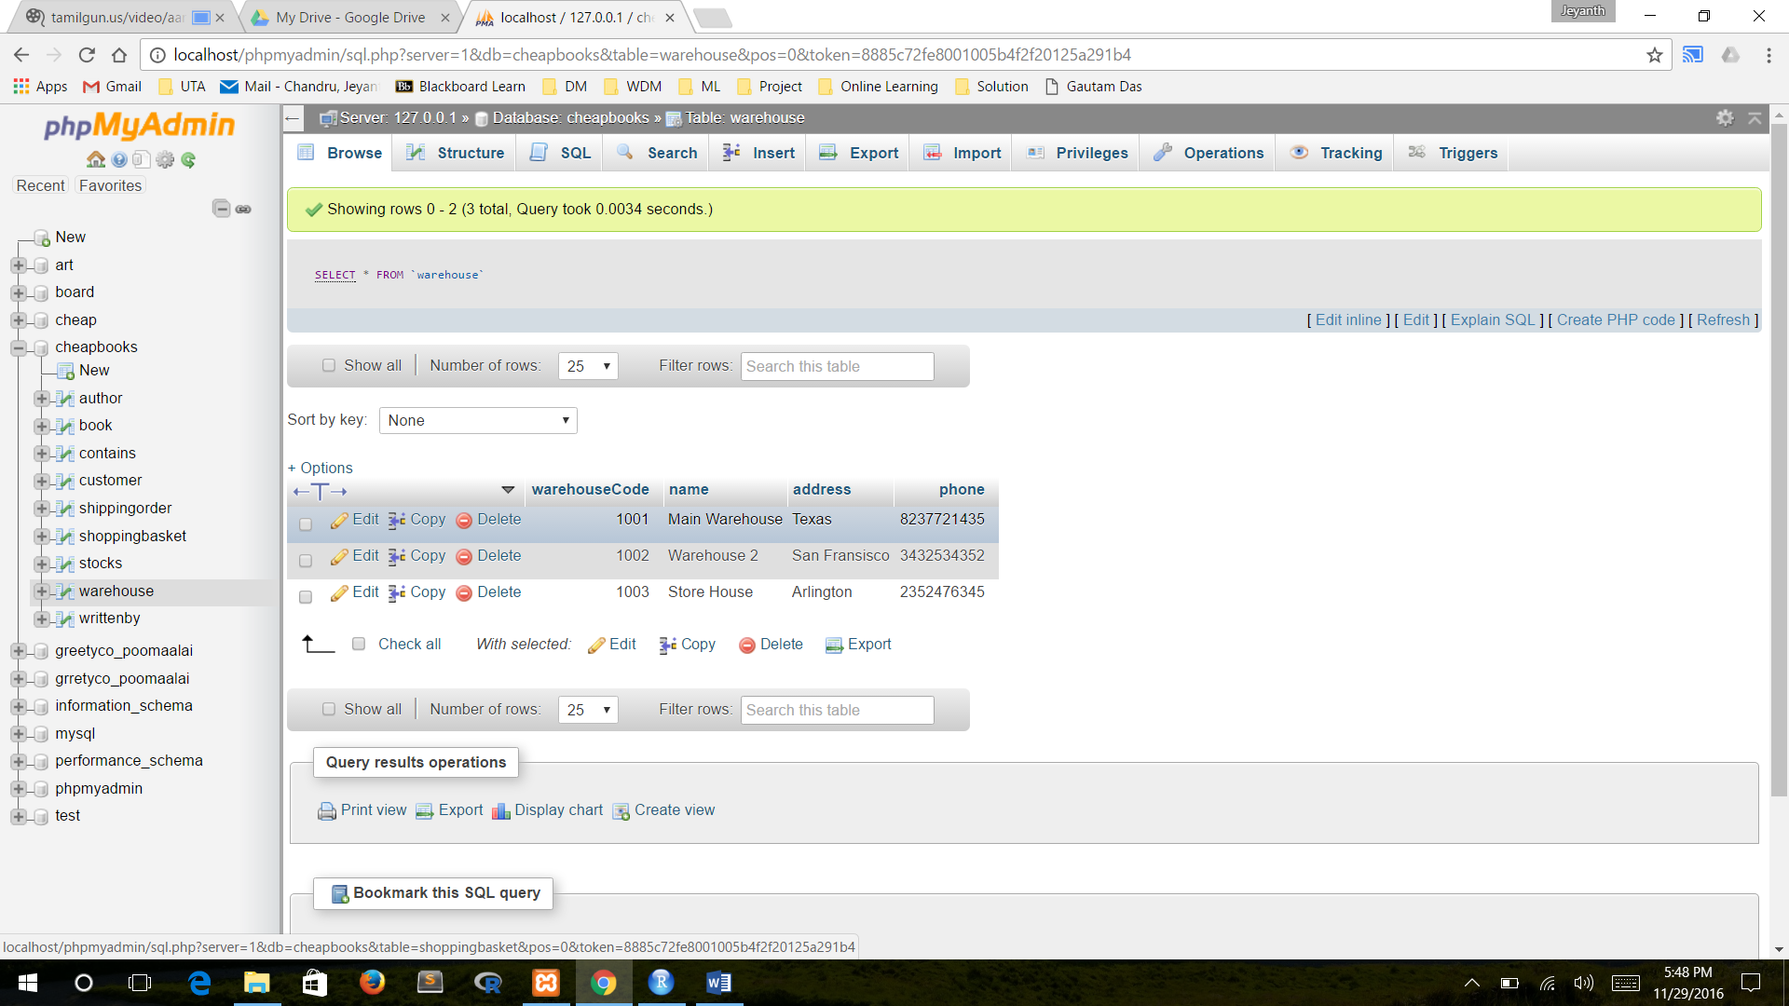

WrittenBy Table

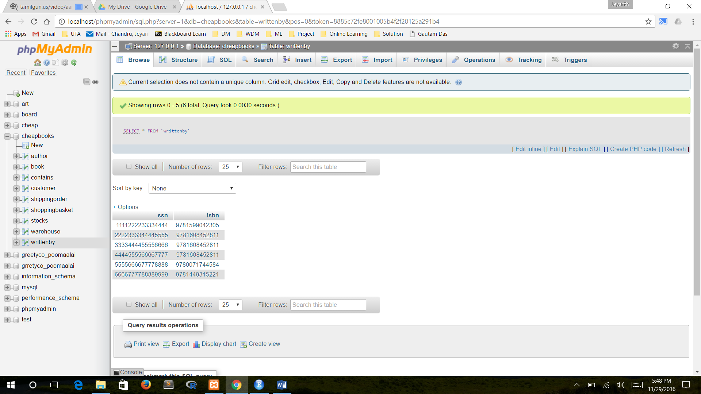

Contains Table

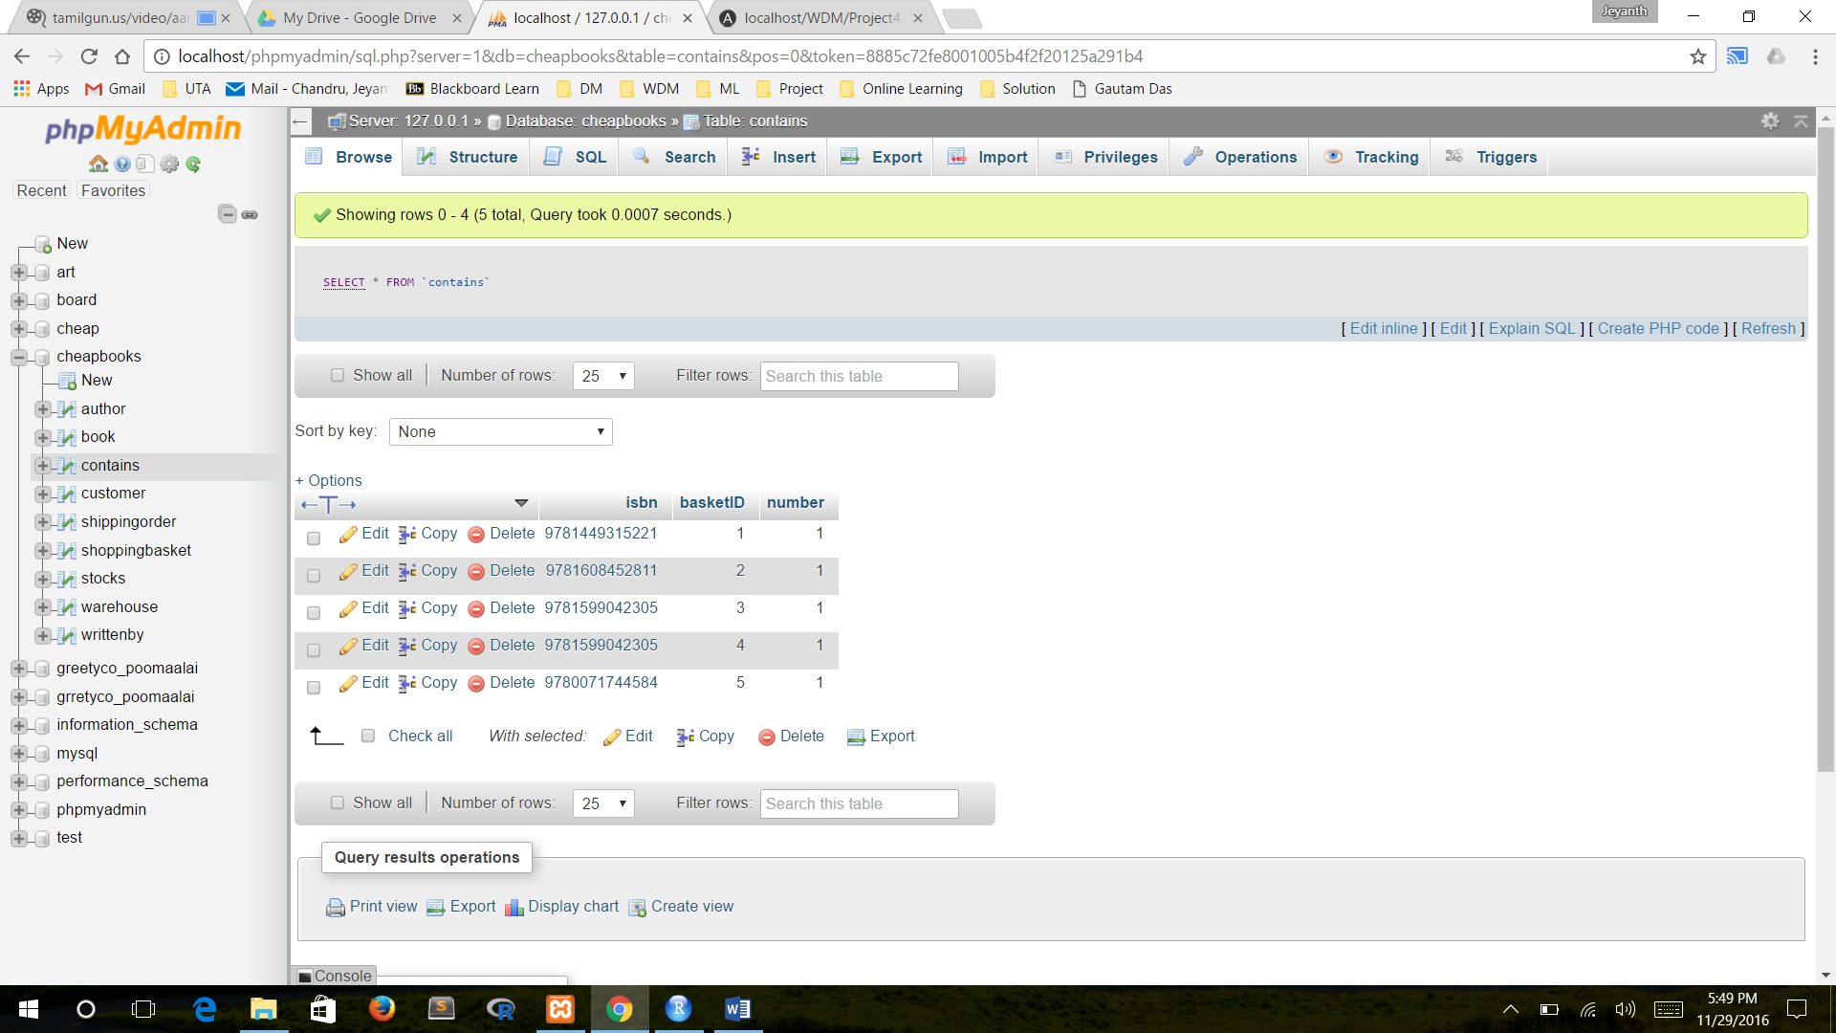

Shopping Basket Table

